A FREE book available to children looked after and young people
We would like to offer you the opportunity to request one of the books listed below which the Virtual School will have delivered to your home address. This offer is part of our commitment to race equality and ensuring this is reflected in the literature children have available at home. The importance of children having access to books where they encounter characters, situations and viewpoints that mirror their own lives, and give them a window into the lives of others is very well documented.
Please select the book you would like for your looked after child/children and share the list with young people so they can make the selection for themselves. The books are linked to target age ranges but remember for younger children you may need to share and read the book with your child.
To request your FREE book, please email VirtualSchool@camden.gov.uk including the selected title, the name of your child/young person and home address.

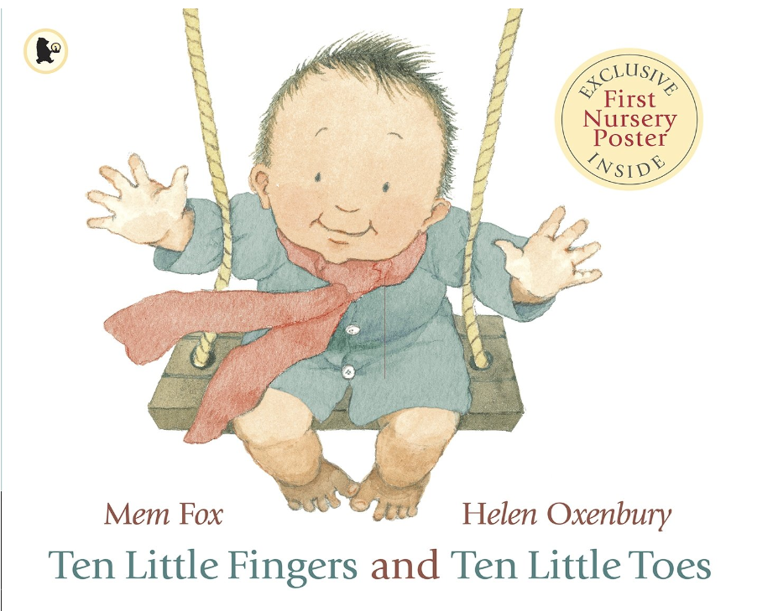 | Age: 0-3 years  All over the world, babies are different. Yet in some ways they are very much the same: each one has ten little fingers and ten little toes – to play with, to tickle, to wave.  With a gently rhyming text and delightfully exuberant illustration, this glorious celebration of babies the world over is a book to treasure.  Ten Little Fingers and Ten Little Toes
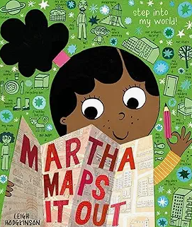 | Age: 3-5  Martha LOVES drawing maps. She creates maps of everything - even her thoughts and dreams! Let Martha be your guide as she welcomes you to her world. Starting in outer space, we zoom in page by page, to our planet, Martha's community, and beyond to her dreams of a future where ANYTHING is possible.  Full of quirky details and fun non-fiction labels that children will love poring over - they will discover cool new facts with every reading. Each map is imbued with an irresistible sense of excitement about the world and optimism for the future.  Martha Maps It Out
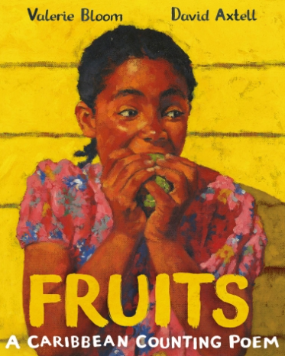 | Age: 5-8  A wryly amusing Caribbean counting poem enumerated in Jamaican Creole. The warm vibrant pictures extend the story of the young narrator and her voracious appetite for the many delicious fruits that careless adults leave around for her to sample as well as share with her little sister.  Fruits

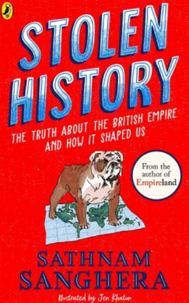 | Age: 9-11  Using accessible and engaging language, Sanghera systematically takes the reader through the colonial histories of many aspects of British society, from cups of tea to Wembley Stadium. Each chapter title is posed as a question, such as "If [the British Empire] was such a big part of history, why don't we know more about it?". Topics covered are incredibly wide-ranging and communicated in a matter-of-fact way. The final chapter, "What can I do?", encourages readers to continue asking questions and show solidarity. How can we ever make the world a kinder, better place for the future, if we don't know the truth about the past?  Stolen History: The truth about the British Empire and how it shaped us
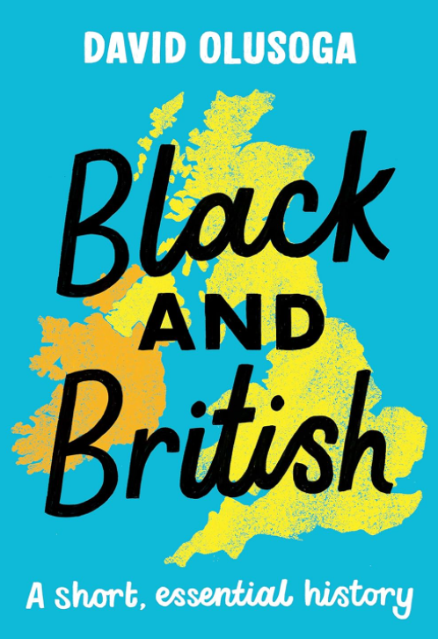 | Age 12+  Winner of the Book of the Year, Children's Illustrated and Non-Fiction at The British Book Awards, 2021  Shortlisted for Waterstones Book of the Year 2020  A short, essential introduction to Black British history for readers of 12+ by award-winning historian and broadcaster David Olusoga.  When did Africans first come to Britain?  Who are the well-dressed black children in Georgian paintings?  Why did the American Civil War disrupt the Industrial Revolution?  These and many other questions are answered in this essential introduction to 1800 years of the Black British history: from the Roman Africans who guarded Hadrian’s Wall right up to the present day.  Black and British: A short, essential history: Amazon.co.uk: Olusoga, David: 9781529063394: Books
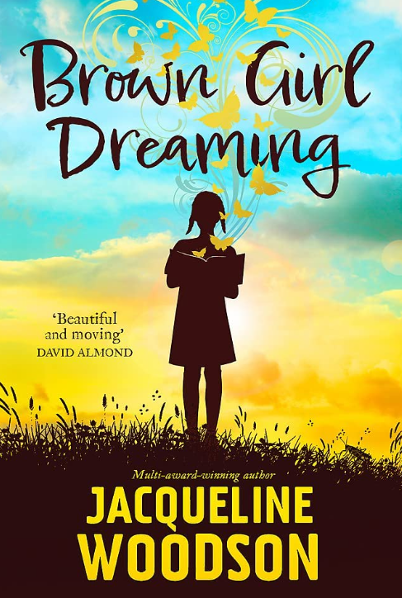 | Age: 11-16  Brown Girl Dreaming is the unforgettable story of Jacqueline Woodson's childhood, sharing what it was like to grow up as an African-American in the wake of the Civil Rights movement, and discovering the first sparks of an incredible, lifelong gift for writing. It's packed with wonderful reflections on family and on place, in a way that will appeal to readers from 11 to adult.  Emotionally charged and touching, each line tells the tale of one girl's search to find her voice, her identity and her place in the world.  Brown Girl Dreaming

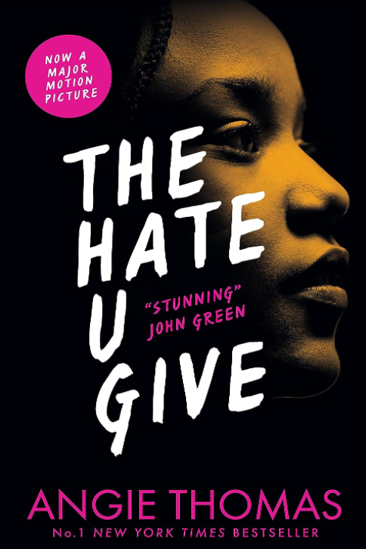 | Age: 14-18  Winner of the Waterstones Children's Book Prize · Goodreads Choice Awards Best of the Best · National Book Award Longlist · British Book Awards Children's Book of the Year · Teen Vogue Best YA Book of the Year  Sixteen-year-old Starr lives in two worlds: the poor neighborhood where she was born and raised and her posh high school in the suburbs. The uneasy balance between them is shattered when Starr is the only witness to the fatal shooting of her unarmed best friend, Khalil, by a police officer. Now what Starr says could destroy her community. It could also get her killed. Inspired by the Black Lives Matter movement, this is a powerful and gripping YA novel about one girl's struggle for justice.  The Hate U Give

