










Information about

Medication
Anticonvulsants
my medication is called

.................................................
.................................................
.................................................
.................................................


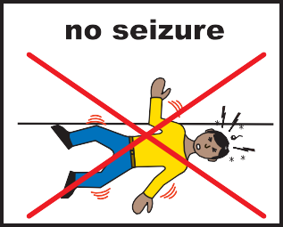
Why have I been given this medication?

Some medications are taken as a ‘course of treatment’ to cure a condition.
Anticonvulsant medications are different.
You need to take them every day to try and stop seizures from happening.
There are different kinds of anticonvulsants for different types of epilepsy. You may need to take more than one anticonvulsant to stop your seizures.

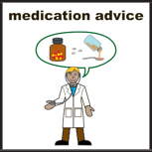
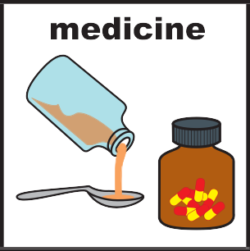
When do I take my medication?
Your doctor will tell you when to take your medication.
Different kinds of anticonvulsants are taken in different ways.
You should take your medication the way the doctor says. If you do not take them in the right way or they might not work very well.
You should not stop taking your medication without talking to your doctor. Suddenly stopping your medication might make seizures start again.


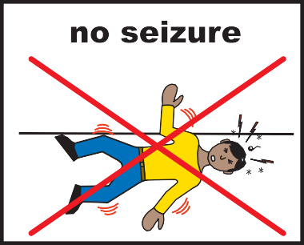
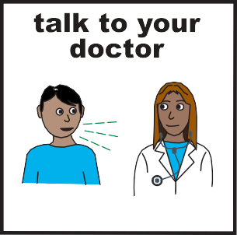
When will I feel better?
It is hard to say how long it will take for your medication to work.

Some people’s medication will start to work quickly.
For some people it may take a longer as they might need to try different medications.
The best way to see if your medication is working is to see if your seizures stop or if you are having less. You might want to keep a seizure diary to check this.
Sometimes a person with epilepsy who has had no seizures for 2 years could ask about stopping their medication. Your medication should only be stopped slowly over several months. You would need to talk to your Doctor about this.

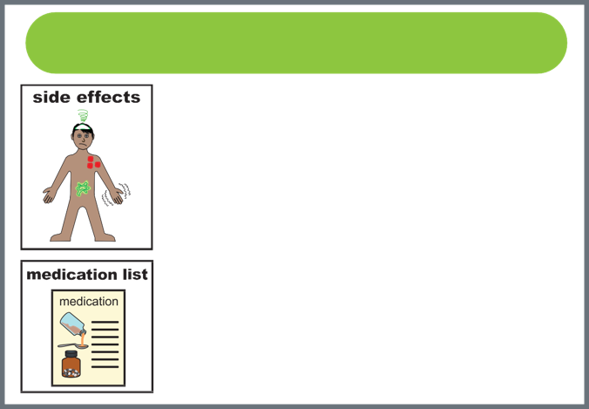
Will there be side effects?
Like all medication anticonvulsants can have
?
side effects.
The side effects will be different depending on which anticonvulsant you take. Different people can have different side effects to the same medication.
Some people think the side effects are better than having seizures.
The side effects will be listed in the patient information leaflet that comes with the medication.

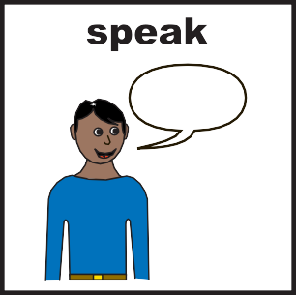




Who do I speak to if I have problems?

If you have any problems with your medication you should tell your

- Pharmacist • Doctor • Epilepsy specialist • Nurse • Carer




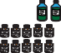
If you want more information about your medication ask your pharmacist

or you could ask your
doctor or nurse

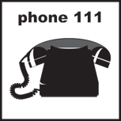

You can get information and advice about your health by calling 111


Or visiting the NHS Choices website at
www.nhs.uk

