Dolly Parton’s
Imagination Library

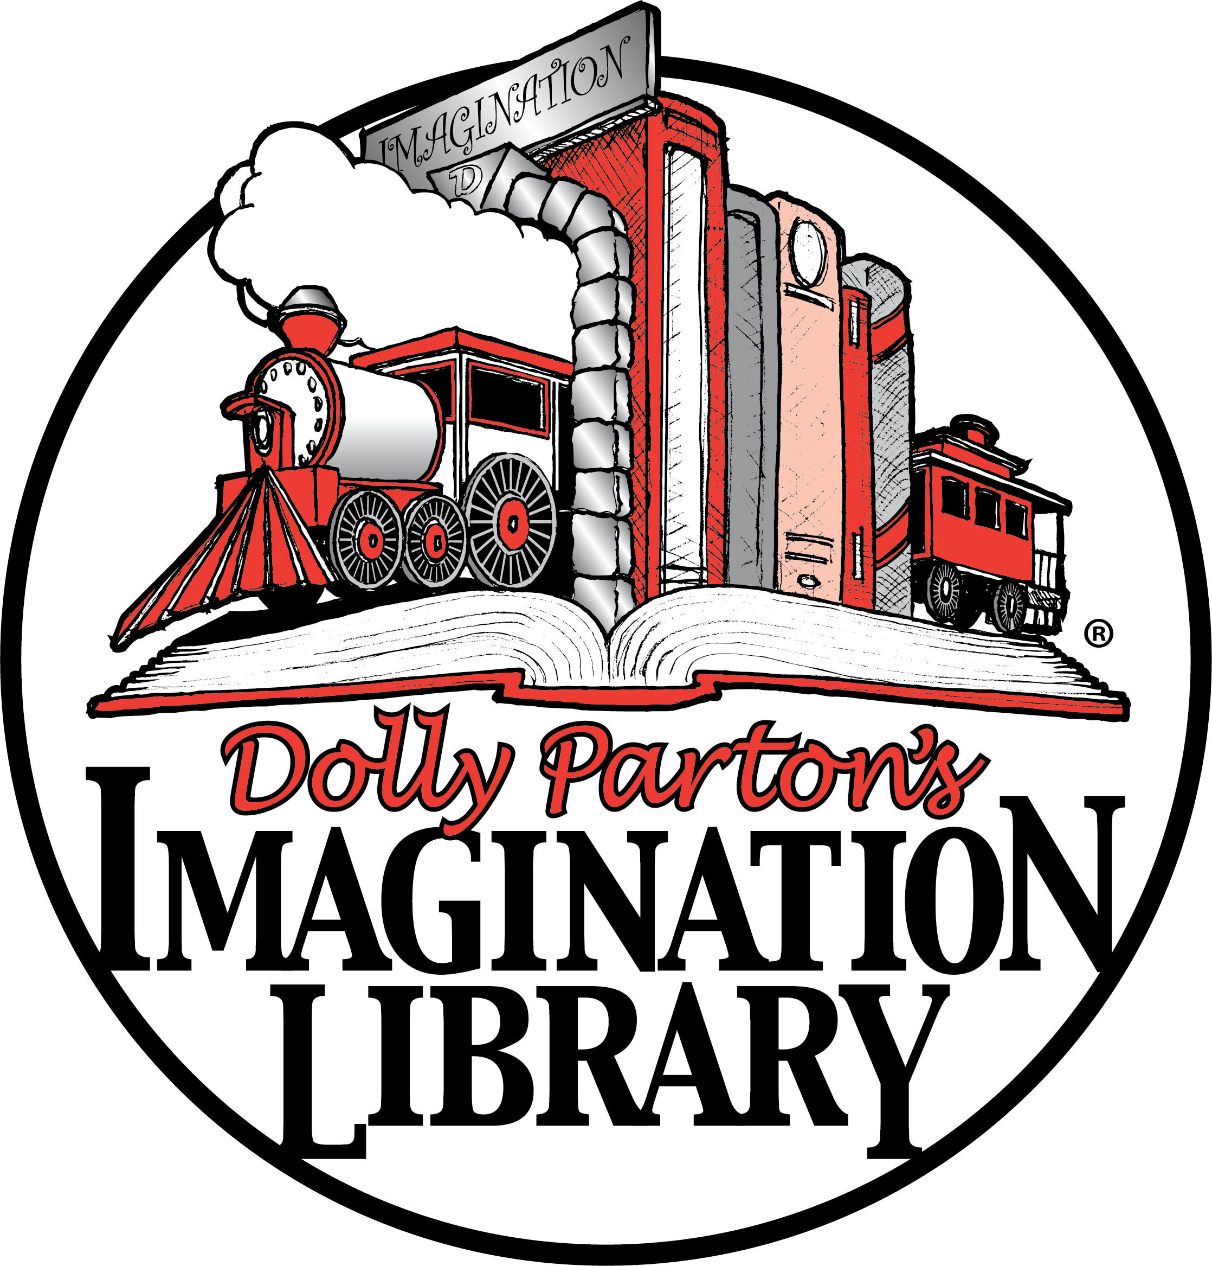

What Is It?

Dolly Parton's Imagination Library is a book gifting programme that mails age-appropriate, high-quality books to children aged under 5. Children receive a free book, addressed to them, through the post to keep, every month until the month they turn 5.

The Imagination Library is Dolly Parton's charity, operated by The Dollywood Foundation UK. Our aim is to promote a lifelong love of books and reading.

Who Is Eligible?

Children under the age of five can register as long as there is a sponsoring partner locally. {Add other eligibility as necessary}

What Are My Responsibilities?

- Submit a registration form, filled out by parent or guardian, and return to your local partner.
- Notify the local partner anytime your address changes. Books are delivered by post to the address listed on the form. If the child’s address changes, you must contact the local partner in order to continue receiving books.
- Read with your child and enjoy the books!

When Will I Receive Books?

The books are ordered a month in advance, this means 4 to 8 weeks after your registration form has been received, books will begin arriving at your home and will continue until your child turns five or you move out of the area.
Dolly Parton’s Imagination Library Official Registration Form (one per child required)

Child’s FULL Name __________________________________________________________________________________________________________

Child’s Date of Birth __________/__________/__________ Phone ___________________________________________

Parent/Guardian’s Name _______________________________________________________________________________________________________________

Child’s Home Mailing Address __________________________________________________________________________________________________________
ADDRESS

__________________________________________________________________________________________________________
ADDRESS

__________________________________________________________________________________________________________
CITY COUNTY POST CODE

Parent/Guardian’s email address (please print very clearly): ___________________________________________________________________________________

“This child is eligible for this scheme.” ___________________________ _______________________________________________________
SIGNATURE OF PARENT OR GUARDIAN

I hereby explicitly consent to allow the Dollywood Foundation, Inc. to use the information provided herein for the purposes of participating in Dolly Parton’s Imagination Library book gifting program. To measure the benefits of this program we may create data sets with the information provided herein and share them with research and educational advancement partners. You agree to review our full Terms & Conditions and Privacy Policy by visiting imaginationlibrary.com. By signing and submitting this form you expressly consent to the terms set forth herein.
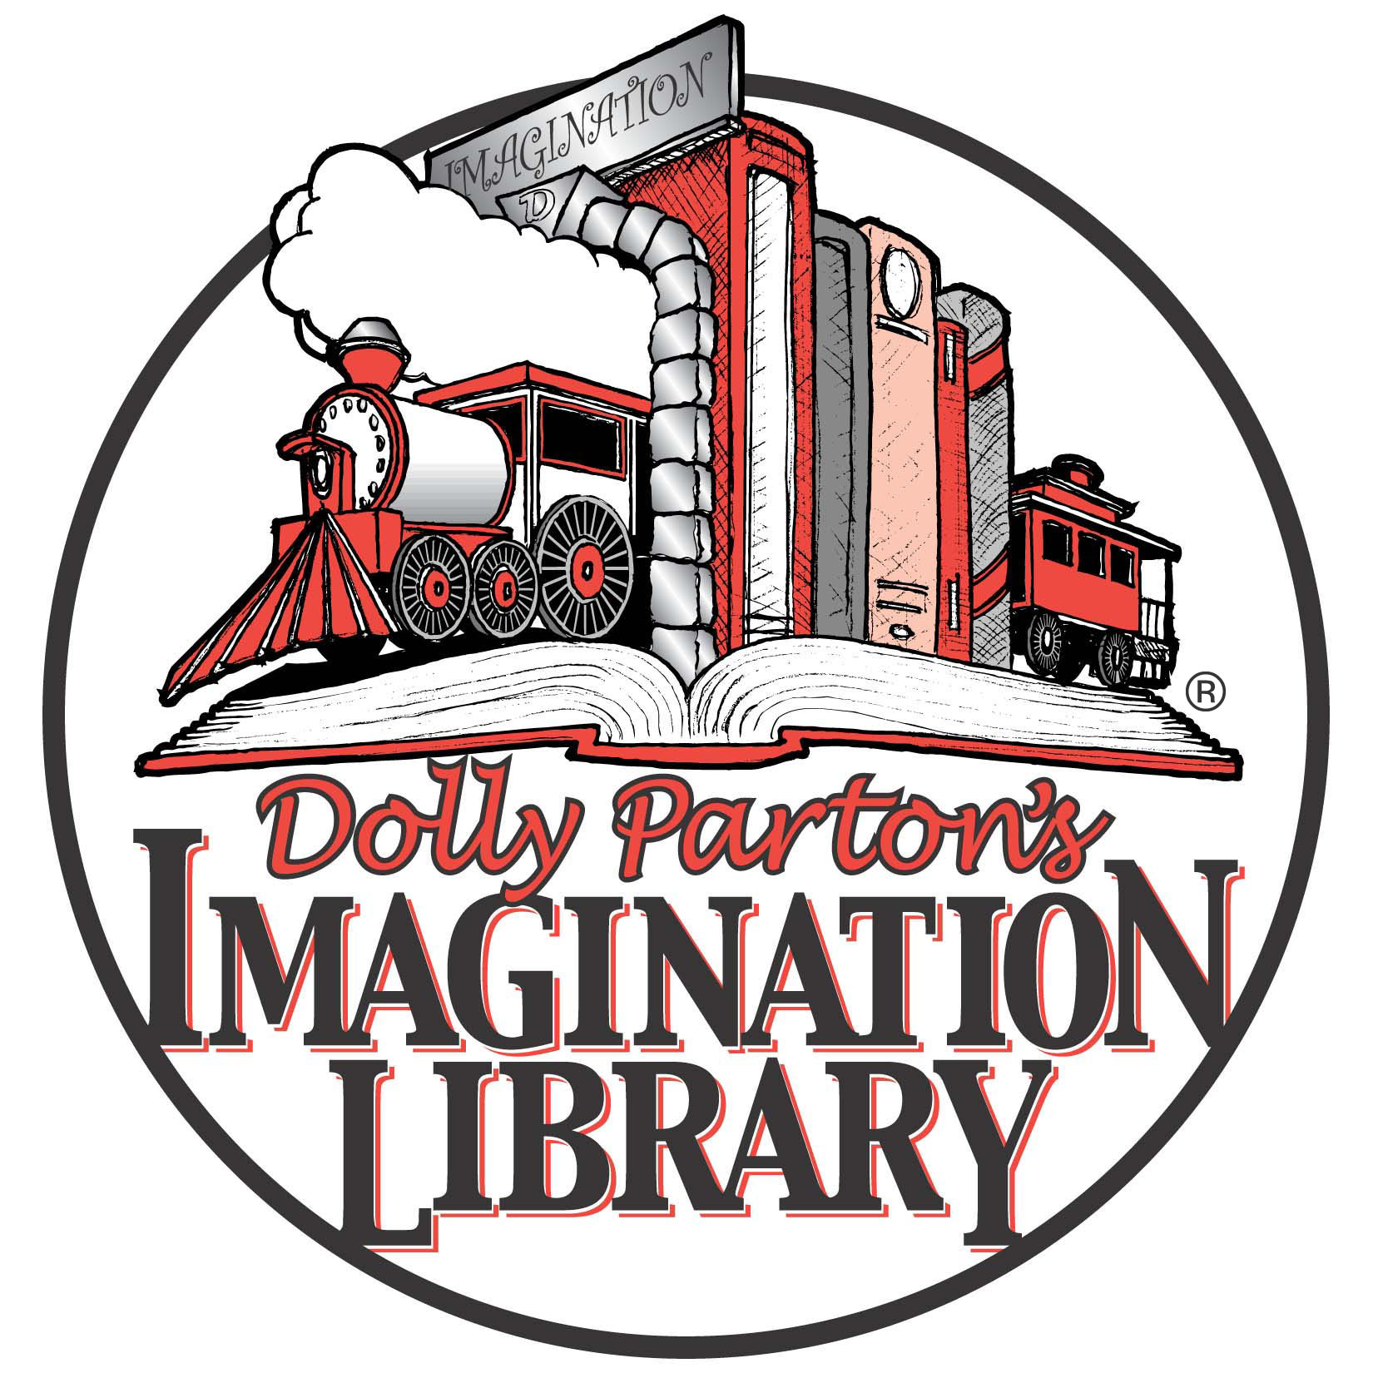

Sign up your
child today!

Simply fill out the form above and return to your local partner. {add local contact details here}

